PROPERTY MANAGEMENT

SYSTEM USING SALESFORCE - DEVELOPER

-------------------------**INTRODUCTION**--------------------

OVERVIEW :

This project focuses on the design and development of a web-enable database management system for the organization and property management system. One of the tasks of any manager is to plan and control the organization in the way that the organization can achieve its goals. Issues relative with the well-being of man like shelter and others issues are very important to take decision in the organization. With the help of property management system those issues would be easily tackle. This property management system is a software where property details such as available house details, schedules, address, and others are been setup by an administrator.

PURPOSE :

The purpose of property management reports is to communicate to the property owner what is going on with their properties. This way, the owner can have a detailed understanding without actually working as much on the specific property.

The property owners achieve this by hiring a reputable property management company. This property management company manages every aspect of the properties and essentially relieves the landlord of all responsibility.

However, landlords will typically require that their property managers provide a property management report. The property managers manage the day–to-day operations of their properties.

---------------------**LITERATURE SURVEY**---------------

EXISTING PROBLEMS :

Problem 1: Guests Trashing Your Properties

Problem 2: The Constant Need for Enhancing Guest Experience

Problem 3: Getting More Direct Bookings

Problem 4: Overbookings

Problem 5: Pricing Management

PROPOSED SOLUTIONS :

Solution 1 : Screen Your Guests Before Handing Your Property to them.

Solution 2: The More You Automate and Personalise the Process, the happier Your Guests Will be.

Solution 3 : Expand Your Online Presence as Much as possible.

· A Direct Booking Website.

· Social Media Platforms.

· Google My Business.

Solution 4 : Using Channel Managers

Solution 5: Use Dynamic Pricing and Deal Analyser Tools

-------------------**THEORITICAL ANALYSIS**---------------

BLOCK DIAGRAMS :

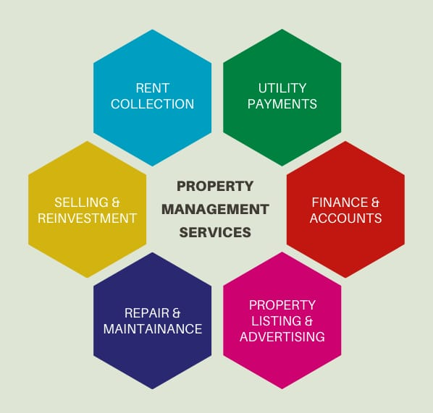



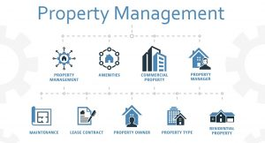

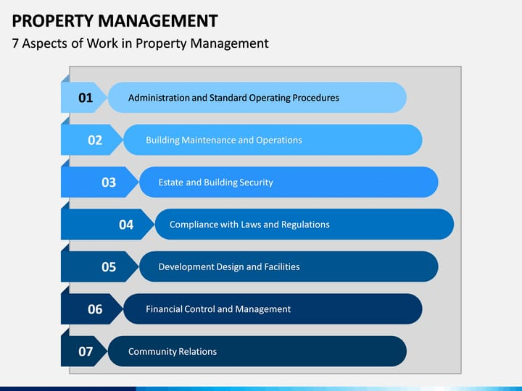



HARDWARE AND SOFTWARE DESIGNING :

Duting system development, i have to design both static and dynamic website interfaces, create website finctions and a database system, edit photos and pictures, so its has a set of software and hardware requirements.

Hardware Used Software Used

* Intel Dual Core Processor **\*** Wamp Server
* 160 GB Hard Disk Drive. **\***  MYSQL,Database
* 1GB RAM **\*** NOTEPAD
* O.S. - Windows XP SP2 **\*** MS PAINT

**At System Users Side**

The following is the requirements for the system users including members and

administrators.

Hardware Requirements Software Requirements

* Intel Pentium 4 Processor **\*** Browser(IE 7.0 or Above
* 20 GB Hard Disk Drive. Mozilla Firefox,Google)
* 256MB RAM
* O.S. - Windows XP **\*** Browser must be
* Browser Must be JavaScript JAVASCRIPT enabled.

----------------------------**RESULT**--------------------------

OUTPUT :

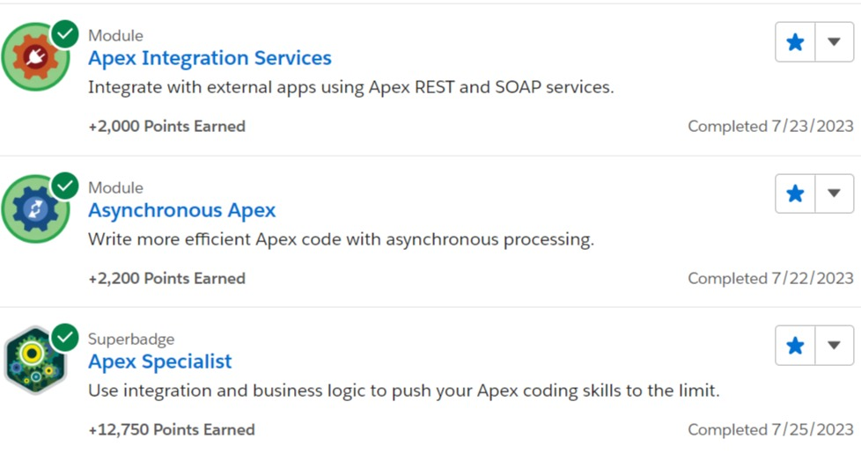



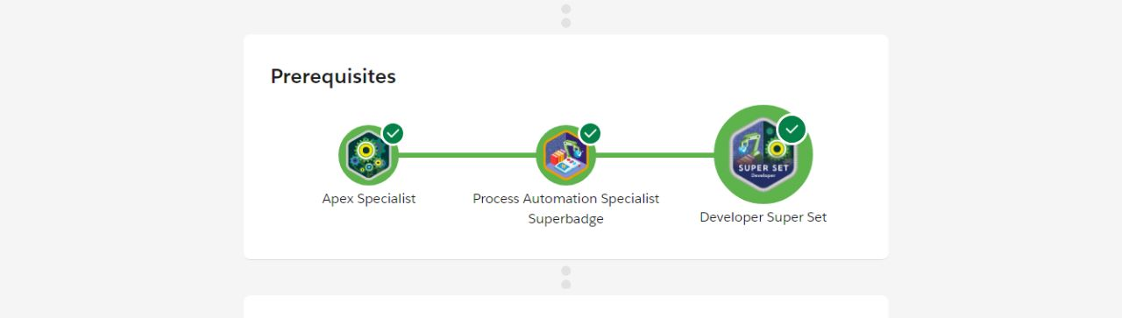



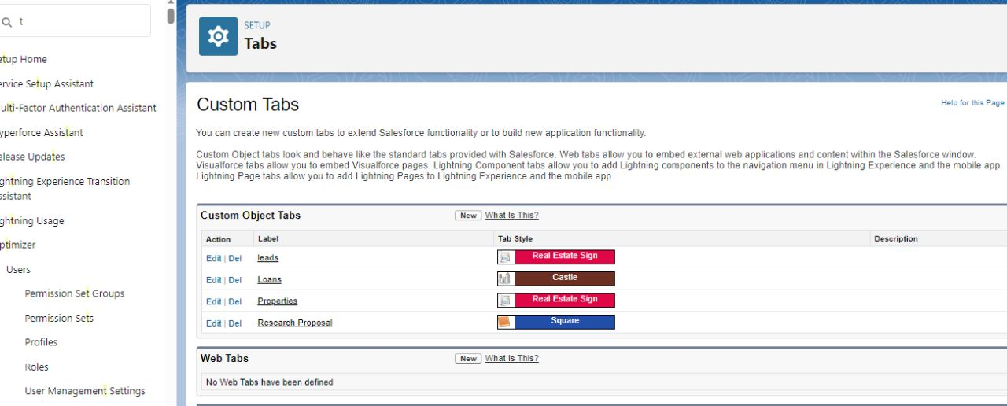

_ADVANTAGES AND DISADVANTAGES_

ADVANTAGES:

* You can access your information from anywhere.
* You’ll save time and money by being more efficient.
* Guest satisfaction may increase with a smooth check-in process.
* You’ll increase bookings by refining your online presence.
* You can optimize your revenue stream using built-in pricing tools.

DISADVANTAGES:

* You’ll be dependent on one vendor.
* Cost can be prohibitive in the beginning.
* All-in-one is not always best.

-----------------------**APPLICATIONS**---------------------

* Bookings
* Check-in and check-out
* Telephone systems integration
* Point of sale (POS) integration
* Event planning
* Food and beverage costing
* Hotel inventory supply management
* Reporting of key performance indicators (KPI)
* Security and room locks

-------------------------**CONCLUSION**-----------------------

* Modify state DOT project development manuals and guidelines to specifically require the involvement of right-of-way personnel in the planning, scoping, andenvironmental phases and the early stages of the design phase.
* Develop a multitier approach for assigning and conducting negotiations.
* Implement web-based database management system to manage the real property acquisition process.
* Separate incentives from the amount believed to be just compensation.

-----------------------**FUTURE SCOPE**---------------------

Property management has long been overlooked in the real estate industry, but the future of property management is brighter than ever. This increased demand is pushing rental rates up faster than income is rising.

* The global property management software market was valued at US$ 14.89 Bn in 2021.
* It is estimated to grow at a CAGR of 8.21% from 2022 to 2031.
* The global property management software market is expected to reach US$ 32.61 Bn by the end of 2031.